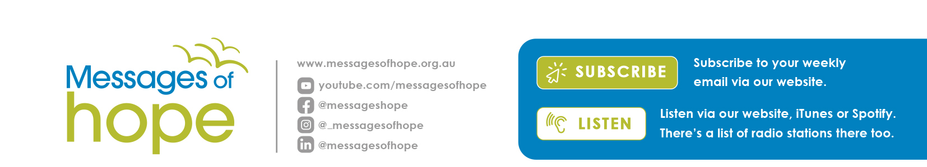

Messages of hope in November 2025

2nd November | Power from above | (Michael Dutschke)
How much of what happens in the spiritual world do you think impacts on your day-to-day living? Michael shares insights into what the bible says about the spiritual realm and what we need to know about the spiritual nature of the Christian faith.
9th November | Letting go of control | (Discussion)
Do you feel stressed trying to meet everyone’s expectations as well as your own? Hear Richard, Celia and Noel share their thoughts on how to deal with stress when it all becomes too much.
16th November | Surviving the streets | (Interview)
Deena shares her heartbreaking story of homelessness and how she was able to break the cycle, finding a community who cares and a sense of belonging.
23rd November | Domestic Violence: getting the facts | (Prof Sarah Wendt)
No one is immune to domestic and family violence. Professor Sarah Wendt is dedicated to understanding the impacts of domestic violence and shares her insights from personal stories about the causes and effects and where we may find hope in such a painful topic. *sensitive content advice*
30th November | Unlocking Ability | (Interview)
When you’re faced with a life of caring for your child with a disability, how do you cope? Hear Chris share the remarkable story of Rachel and how she’s found purpose despite her limitations.
Gifts of Hope
Bring hope to your community — one bag at a time!
Do you know an organisation you’d like to bless with a gift of hope?
We want to reach as many people as we can with Messages of hope.
So, with your donation of $30, Lutheran Media will send a Gifts of Hope bag
filled with encouraging, hope-filled booklets and resources to an aged care home, op shop, school or community centre in your area. Find out more at www.lutheranmedia.org.au/giving/gifts-of-hope-bags or contact us at office@lutheranmedia.org.au or phone 1800 353 350.
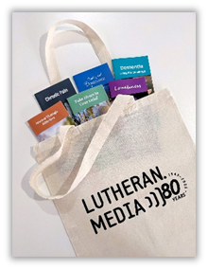

Prayer Requests
- For the victory over death and the power of Christ in spiritual warfare.
- For people feeling stressed and overwhelmed.
- For people facing homelessness and displacement.
- For families coping with crisis or challenges.

Resources in November

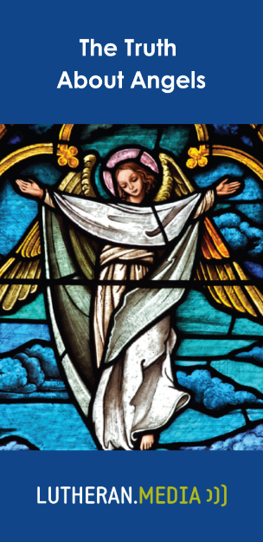  https://messagesofhope.org.au/the-truth-about-angels-booklet/ | 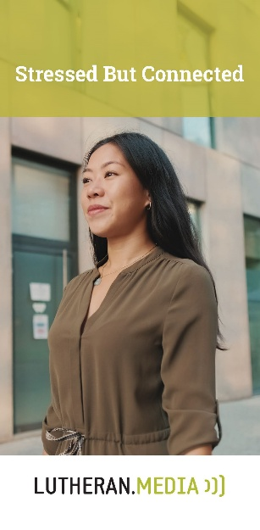  https://messagesofhope.org.au/stressed-but-connected-booklet/

Lutheran Media 2026 Calendars – Available NOW!
Get in quick to order our 2026 Lutheran Media Calendar fresh off the press!
This issue is full of inspiring images and bible verses with space to write your important diary dates. It’s a centrepiece worthy of prominence in any household!
To order, go to www.lutheranmedia.org.au/calendar or contact us at office@lutheranmedia.org.au or phone 1800 353 350.
